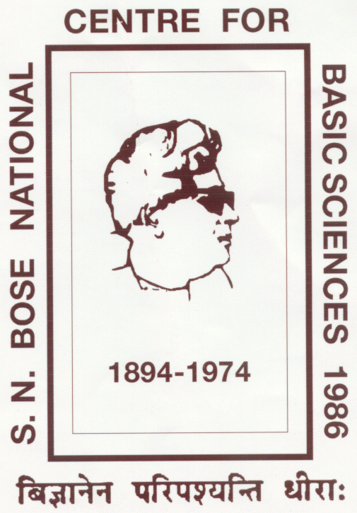 | S. N. BOSE NATIONAL CENTRE FOR BASIC SCIENCES  Block – JD, Sector – III, Salt Lake, Kolkata – 700106, India
Advanced Post-doctoral Manpower Programme (APMP)  APPLICATION FORM FOR PDRA POSITION |  |  |  | Passport  Size  Photo
Position Applied For  (tick the appropriate, strikeout the inappropriate) |  |  | PDRA – I  PDRA – II  PDRA – III
Personal Details
Name (in CAPITAL)
Date of Birth (dd/mm/yyyy) |  | ____/____/________ | Age  (as on date of application)
Nationality
Email Id (s)
Mobile Number (s)
Permanent Address
Address
Post Office
Police Station
District
State
Pin
Address for Correspondence
Address
Post Office
Police Station
District
State
Pin

Educational Qualification (if required, attach extra sheet maintaining the table structure)
Examination | Board / University | Year | Percentage / Grade | Division
B. Sc.
M. Sc.

Doctoral Degree
Thesis Title
Thesis Supervisor
University / Institute
If Thesis Submitted, Date of Submission (dd/mm/yyyy) | ____/____/________ | If PhD Awarded, Date of Award  (dd/mm/yyyy) | ____/____/________
Field of Research
Current Affiliation
Position
Organization
Publications
Published/Accepted in Referred Journal (number only)
Postdoctoral Experience (including current position; if required, attach extra sheet maintaining the table structure)
Organization | Position | From | To | Mentor

List of Referees (Name, Affiliation & Email for each)
Referee 1 | Referee 2 |  | Referee 3
Choice of Mentor at SNBNCBS (in order of preference)
Mentor 1 | Mentor 2 |  | Mentor 3
Checklist for Annexures (tick the appropriate)
Certificates of Educational Qualification |  | Attached |  | Not Attached
Proof of Doctoral Degree / Thesis Submission |  | Attached |  | Not Attached
List of Publications |  | Attached |  | Not Attached
Experience Certificate(s) (if any)  (also required for current position, if employed) |  | Attached |  | Not Attached
Research Proposal at SNBNCBS |  | Attached |  | Not Attached
Updated Curriculum Vitae |  | Attached |  | Not Attached
Any Other Relevant Information
Declaration
I hereby certify that all information provided in this application and any attachments is true and complete. I understand that any false information or omission may disqualify me from further consideration for employment, or, if I am hired, may result in my dismissal from employment if discovered at a later date.
Date: |  | Signature

